Assignment 3

|  |  |
| --- | --- |
| Assignment Date | 07 October 2022 |
| Student Name | Kurinjilan |
| Student Roll Number | 311019104302 |
| Maximum Marks | 2 Marks |

# Question 1:

Create a bucket in IBM object storage.

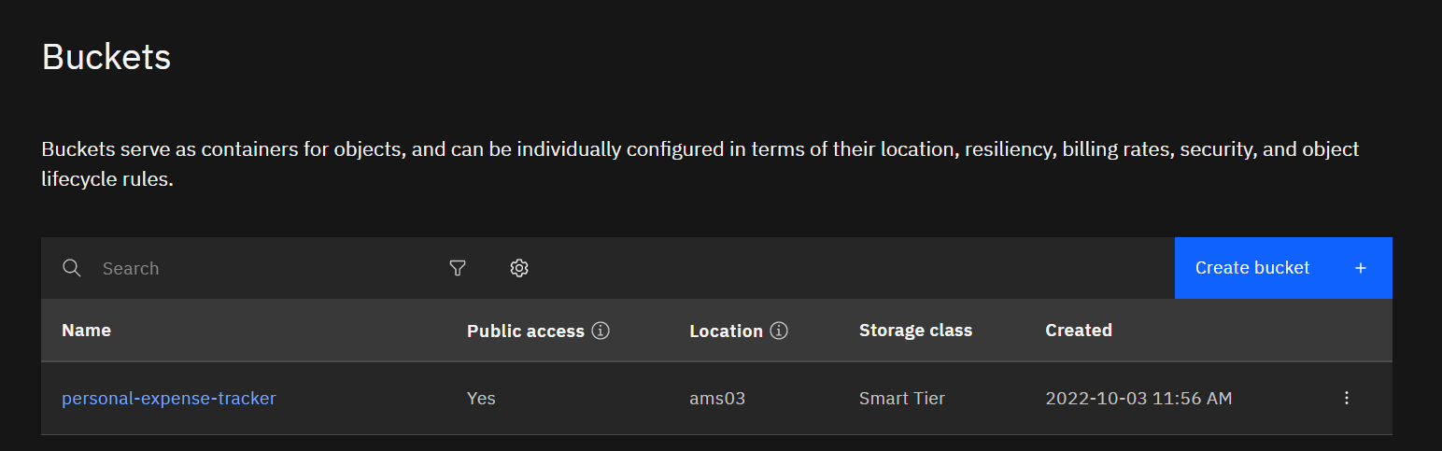

03-11-2002

**Question 2:**

Uploadany5imagestoIBMobjectstorageandmakeitpublic.WriteHTML code to displaying all the 5 images

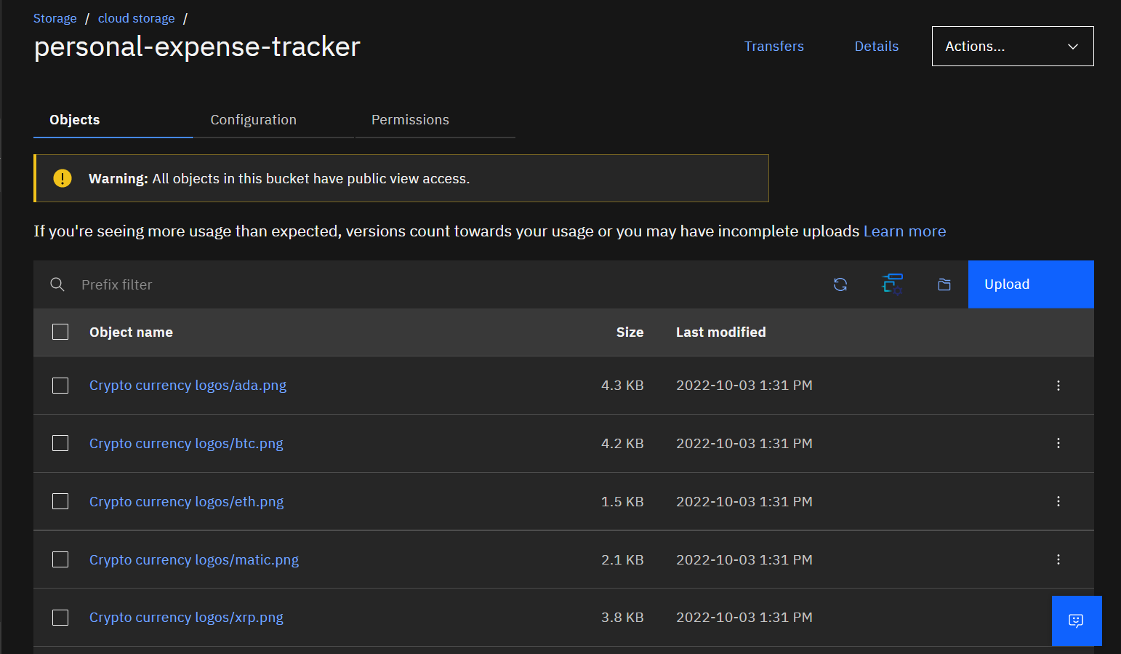

HTML code for displaying images in cloud

<!DOCTYPE html>

<html lang="en" dir="ltr">

<head>

<meta charset="utf-8">

<title>Crypto currencies</title>

</head>

<body>

<h1>Popular Cryptocurrencies</<h1>

<h2>1 Bitcoin BTC </h2>

<img

src="https://personal-expense-tracker.s3.ams03.cloud-object-storage.appdomain. cloud/Crypto%20currency%20logos/btc.png" alt="Bitcoin">

<h2>2 Ethereum ETH</h2>

<img

src="https://personal-expense-tracker.s3.ams03.cloud-object-storage.appdomain. cloud/Crypto%20currency%20logos/eth.png" alt="Ethereum">

<h2>3 Polygon MATIC</h2>

<img

src="https://personal-expense-tracker.s3.ams03.cloud-object-storage.appdomain. cloud/Crypto%20currency%20logos/matic.png" alt="Polygon">

<h2>4 Ripple XRP</h2>

<img

src="https://personal-expense-tracker.s3.ams03.cloud-object-storage.appdomain. cloud/Crypto%20currency%20logos/xrp.png" alt="XRP">

<h2>5 Cardano ADA</h2>

<img

src="https://personal-expense-tracker.s3.ams03.cloud-object-storage.appdomain. cloud/Crypto%20currency%20logos/ada.png" alt="Cardano">

</body>

</html>

HTML Output for displaying images from IBM cloud storage:

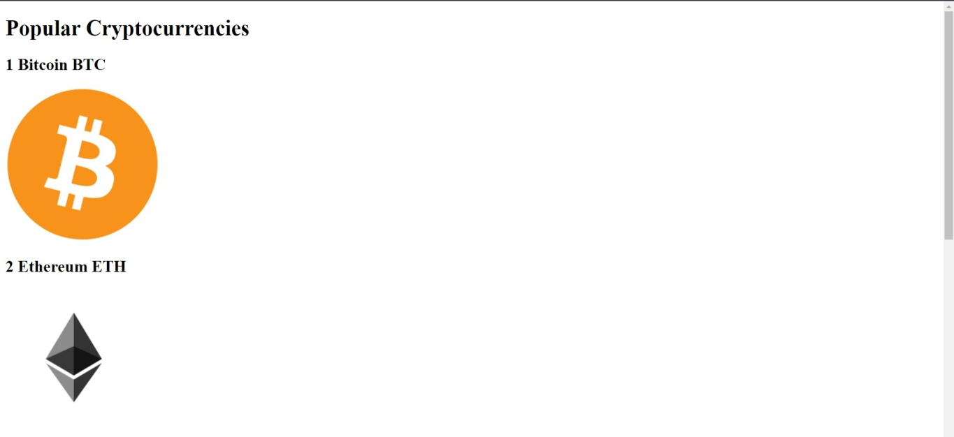

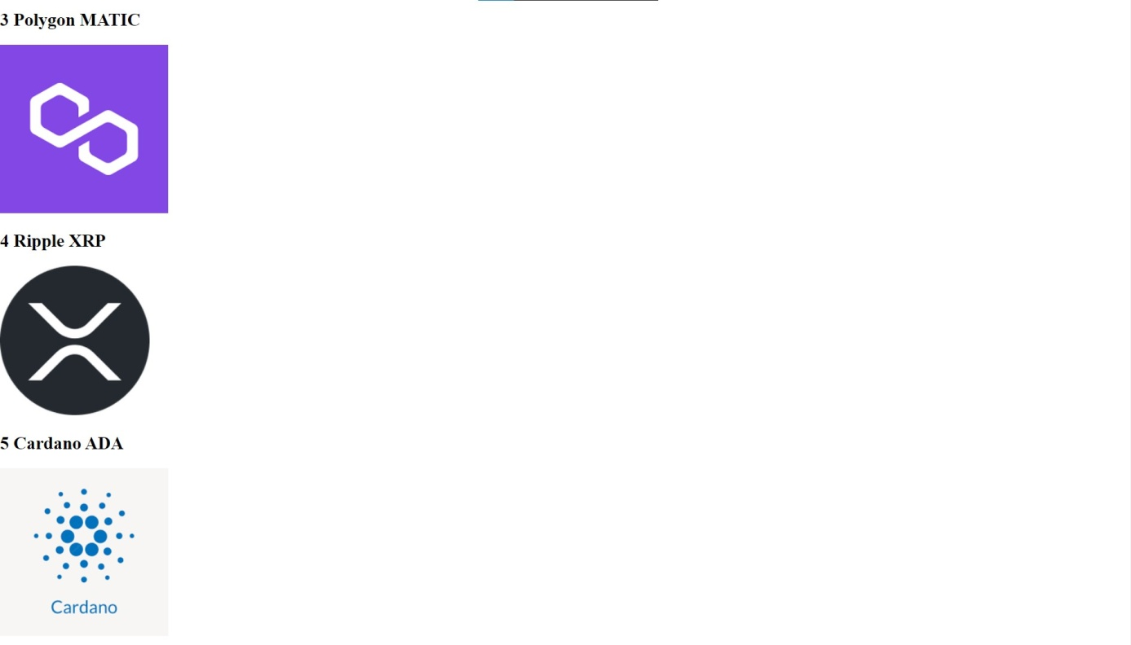

**Question 3:**

UploadaCSSpagetotheobjectstorageandusethesamepageinyourHTML code.

HTML code with CSS ﬁle present in IBM cloud storage:

<html>

<head>

<title>Home page</title>

<link rel="stylesheet"

href="https://personal-expense-tracker.s3.ams03.cloud-object-storage.appdomain

.cloud/style.css">

</head>

<body>

<h1>Hi there</h1>

<p>HereistheCSSfilepresentinIBMcloudstorage <a

href="https://personal-expense-tracker.s3.ams03.cloud-object-storage.appdomain

.cloud/style.css">Click here</a></p>

</body>

</html>

HTML code output:

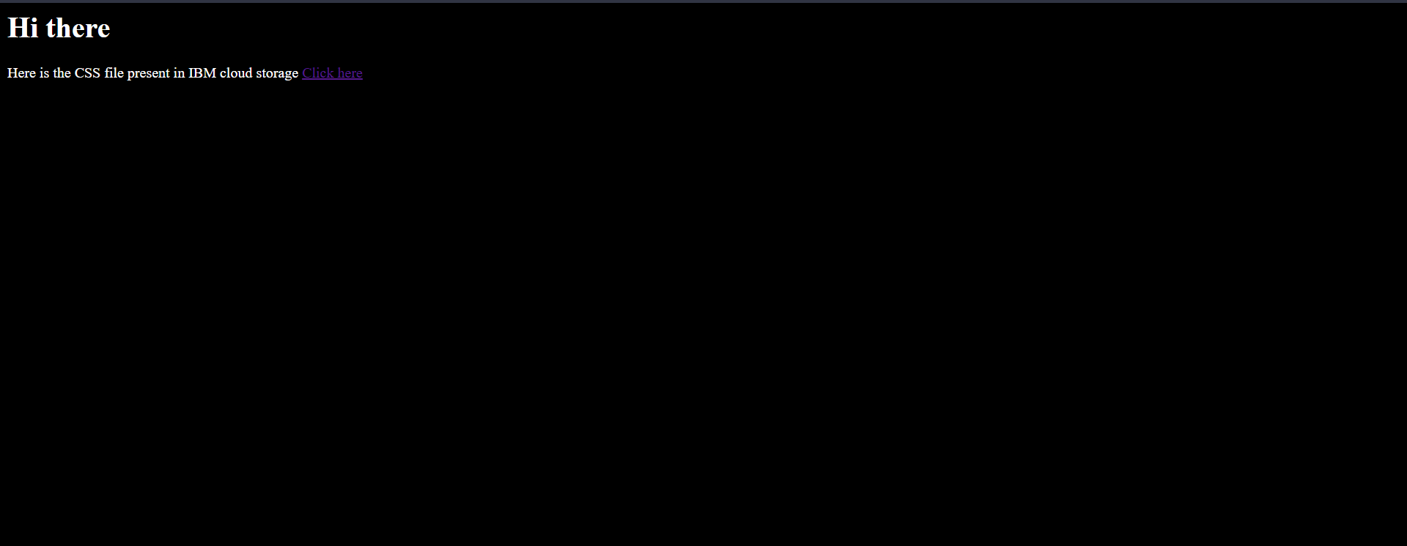

CSS ﬁle in Cloud object storage

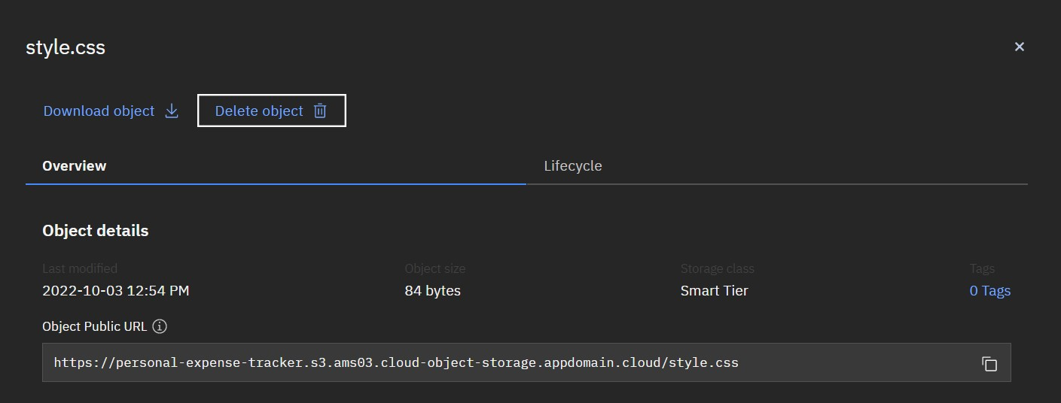

2022-10-03

**Question 4:**

DesignachatbotusingIBMWatsonassistantforhospital.Ex:Usercomeswith querytoknowthebranchesforthathospitalinyourcity.SubmitthewebURLof thatchatbotasaassignment.

WatsoaAssistant —

Welcome, how can I assist you?

appointment booking

please select the preferred branch location

Delhi Numbai Chennai

ftotkata

Please select the preferred timing for appointment.

9:30am 11:30am 2:3Opm

5:00pm

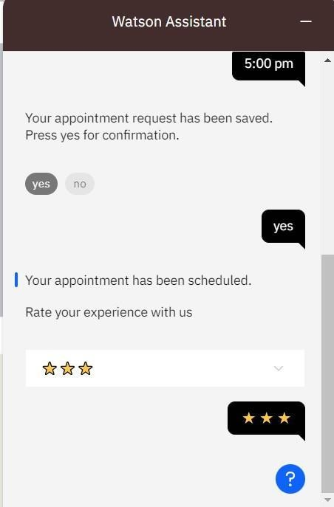

# Question 5:

CreateWatsonassistantservicewith10stepsanduse3conditionsinit.Load thatscriptinHTMLpage.

Script in HTML page:

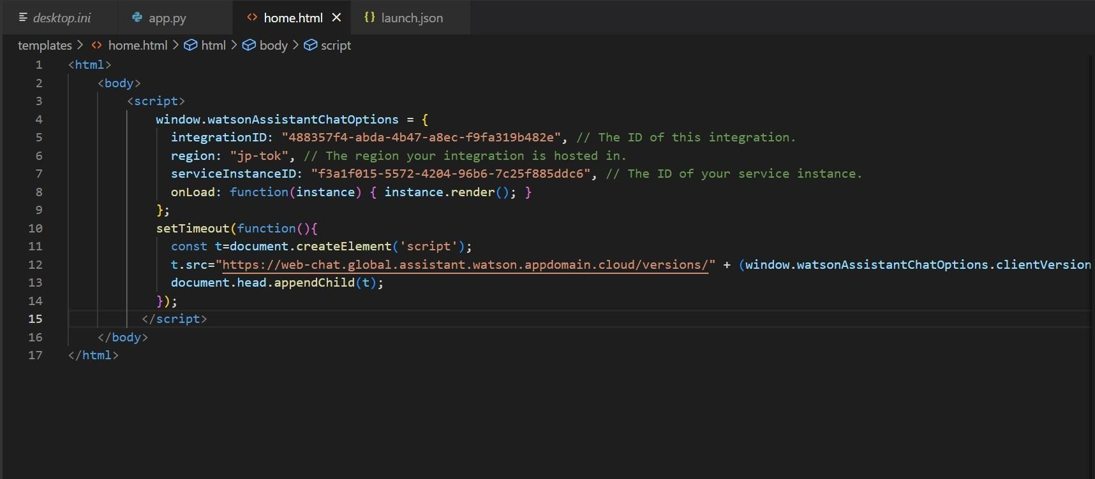

Food-ordering bot:

## WatsonAssistant —

Welcome, how clanI assist you?

orderfood

### Select the food item









WatsonAssistant —

## Fordeliveryweyvillneedafewpiecesof information.Letmeguideyouthroughthis process!

#### First, please provide your first name.



Thanks! Now, enter your last name.

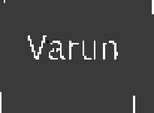

Awesome. I’llatsoneed an email address associated with your new account. We will send you the delivery details to your email

Which email address would you like to use?



WatsonAssistant —

## Enter the delivery location

12 th Street Manali newtown

We need your i›hone nunbcrto contact you. Would you like to do so?

#### Yes, I'd like to add a phone numbers

Yes,I'llliketoaddai›hone number.

O kay, please enter your phone number below.

l234o6789

Watson Assistant —

Please enter a vahdwho ne nrimbei.



6482973043

Thands!DocsthefolloWinginformationlook correct?Ifso,IWillproceeda•itI1placingyour order

* Name: Var unArun
* EmailAddress:‹zrrinvarun •maiI.com
* Phone Number:6482973043
* Delivery Location: 12 thStreetManali

IU WtOW II



## WatsonAssistant —

### EmailAddress:ai”unvñLLIf1 gn1‹ail.com “

* Phone Number:6482973043
* Delivery Location: 12 thStreetManali

I1C WtOW II



#### Yourorderwillbeuclivcredwithin30mins!You will receive ancmaiI contrmationshortly.

WeSCO 0!